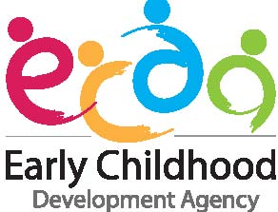

ECDA TRAINING AWARD (UNIVERSITY) APPLICATION FORM
(Applicant’s Write-up)

Instructions to Applicants:
- Please download and complete all items in this application form. For items which are not applicable, please indicate ‘N.A’. Any omission of information requested in the application form or of supporting documents will cause delay and may render the application void.
- Section 1 and 2 of this form are to be completed by the applicant.
- Please attach this completed form under Section (E) Supporting Documents on FormSG online application form.

1) APPLICANT’S PERSONAL PARTICULARS
Name as in NRIC or Passport (Please underline surname):  Choose a salutation. : Click here to enter name. | NRIC (Choose an item.):  Click here to enter text.
2) APPLICANT’S WRITE-UP
This write up is important in the evaluation of the Training Award. Please answer all questions.

- Personal write-up of not more than 500 words, including:
- Reasons for applying for the ECDA Training Award, incorporating your personal philosophy, values, and beliefs as an Early Childhood Educator.
- Your professional aspirations during and/or after your studies and aspirations for the Early Childhood sector.
- Any contributions to the early childhood sector or participation in children-related events/activities.
- Any other relevant information that will help us know you better.

- Share your view in not more than 500 words, some strategies which you think will be helpful to attract, develop and retain the right talents for the Early Childhood sector.

Click here to enter text.

